Maximizing Sales Through Strategic Product Bundling

**A Mid-term report for the BDM capstone Project**

Submitted by

Name:Kavya XXXXXXX

Roll number: XXXXXXXXXX



IITM Online BS Degree Program,

Indian Institute of Technology, Madras, Chennai

Tamil Nadu, India, 600036

**Contents**

1 Executive Summary and Title (200-250 Words) 2

2 Proof of originality of the Data (Primary Data - survey link,

photograph, letter from organization, etc.)

3 Metadata- 20 marks

● Descriptive Statistics- 20 marks

4 Detailed Explanation of Analysis Process/Method

5 Results and Findings (Graphs and other Pictorial Representation

Preferred and with words)

# Executive Summary and Title (200 Words)

The project centers on XXXXXX Company, a leading wholesale distributor situated in Raebareli.   
The company is located at (address), specializing in supplying a wide range of goods to retail establishments and small businesses. The Company operates in the B2B segment within the region. With a focus on maximizing profitability and expanding its customer base, the company aims to optimize operations and implement strategies for sustainable growth.

The primary challenge addressed in this project is to analyze sales performance and profitability across product categories. This includes identifying key factors affecting profitability, such as pricing strategies, profitability and product bundling. Additionally, understanding customer preferences and market trends plays a crucial role in driving decision-making processes within the organization.

The project's primary challenge involves analyzing sales performance, profitability across product categories, and understanding retailer behavior, particularly focusing on identifying key factors impacting profitability such as pricing strategies. The goal is to pinpoint the most and least profitable products to enhance the overall profitability of the company.

The approach undertaken in this project involves thorough data cleaning to ensure data accuracy and reliability. This step is crucial in deriving meaningful insights from the data provided by the organization. By analyzing sales data and market trends, the aim is to identify high-performing products and strategize ways to increase the sales of underperforming products. The expected outcome includes creating product bundles and combos to improve the performance of less-selling products, thereby optimizing sales strategies and boosting the profitability of the company across its product portfolio. Additionally, leveraging methodologies such as the Pareto Principle, ABC Analysis, and SWOT analysis can provide valuable insights and strategic direction in addressing the challenges faced by XXXXXXCompany. These analytical frameworks will help prioritize efforts, identify critical areas for improvement, and capitalize on opportunities for growth and profitability within the organization's product offerings.

# Proof Of Originality of Data

## **Letter Of Authentication:**



# Metadata and Descriptive Statistics:

## **Sales Data** captures transactions from April 2023 to June 2023, including details of products sold and quantities ordered

* *SKU (Stock Keeping Unit)*: A unique identifier for each product in the Company's inventory.
* *Product Name*: The name of the product corresponding to the SKU.
* Buyer: Name of the business to which the products were sold
* Date : Date on which the order was made by the buyer
* Month: The month in which the order was made
* Month:
* *Quantity*: The number of units of a particular SKU ordered
* *Selling Price*: The price at which Company sells the products to retailers/buyers
* Cost Price: Cost price of the product for the supplier
* Profit (per unit): The profit company makes by selling one unit of the product.
* Profit : The profit made by the company in that particular order. (profit per unit times order quantity)

**Product Sale Data**: Focuses product-specific sales information for April to June 2023. It includes Units sold in each month (April, May, June) , Total Sales for each month, and Product Name. This data facilitates understanding of product-wise sales trends, demand patterns, and revenue generation.

* Units sold(April): Total number of units of a particular product sold in April 2023.
* Units sold(May): Total number of units of a particular product sold in May 2023.
* Units sold(June): Total number of units of a particular product sold in June 2023.
* Total Sales April: Total sales of a particular product in April 2023, calculated as the selling price * units sold in April.
* Total Sales May : Total sales of a particular product in May 2023, calculated as the selling price * units sold in May.
* Total Sales June : Total sales of a particular product in June 2023, calculated as the selling price * units sold in June.

**Product Revenue Details** : Provides comprehensive details about product revenue and profitability for April to June 2023. It contains SKU, Product Name, Total Units Sold, Units Sold in each month, Selling Price, Cost Price, and Profit details. This data enables analysis of product-level performance, pricing strategies, and overall contribution to company profits.

* SKU: Stock Keeping Unit, a unique identifier for each product in the company's inventory.
* Product Name: Name of the product corresponding to the SKU.
* Total Units Sold: Total number of units of a particular product sold from April to June 2023.
* Units Sold April : Total number of units of a particular product sold in April 2023.
* Units Sold May : Total number of units of a particular product sold in May 2023.
* Units Sold June : Total number of units of a particular product sold in June 2023.
* Selling Price : The price at which the company sells the products to retailers/buyers.
* Cost Price: Cost price of the product for the supplier.
* Profit April : Profit made from a particular product in April 2023, calculated as the sum of profit for each unit sold in April.
* Profit May : Profit made from a particular product in May 2023, calculated as the sum of profit for each unit sold in May.
* Profit June: Profit made from a particular product in June 2023, calculated as the sum of profit for each unit sold in June.
* Total Profit: Total profit made from a particular product from April to June 2023, calculated as the sum of profit for each unit sold during this period.

**Buyer Data**:

Provides insights into sales and profitability metrics for different buyers during April to June 2023. It includes Total Sales and Profit details for each buyer in April, May, June, and the overall period. This data helps in evaluating buyer-specific performance and contribution to overall revenue and profit.

* Buyer: Name of the business to which the products were sold.
* Total Sales April: Total sales made in April 2023 by a particular buyer, calculated as the sum of selling price * quantity for all products sold to that buyer in April.
* Total Sales May: Total sales made in May 2023 by a particular buyer, calculated as the sum of selling price * quantity for all products sold to that buyer in May.
* Total Sales June: Total sales made in June 2023 by a particular buyer, calculated as the sum of selling price * quantity for all products sold to that buyer in June.
* Total Sales: Total sales made by a particular buyer from April to June 2023, calculated as the sum of selling price * quantity for all products sold to that buyer during this period.
* Profit April: Profit made in April 2023 by a particular buyer, calculated as the sum of profit for each product sold to that buyer in April.
* Profit May: Profit made in May 2023 by a particular buyer, calculated as the sum of profit for each product sold to that buyer in May.
* Profit June: Profit made in June 2023 by a particular buyer, calculated as the sum of profit for each product sold to that buyer in June.
* Total Profit: Total profit made by a particular buyer from April to June 2023, calculated as the sum of profit for each product sold to that buyer during this period.

*You can view the data by clicking* [*here*](https://docs.google.com/spreadsheets/d/1WkeKQFIhU3UKPpLSjYpEM28tEco47NRtPoihkj90Lcs/edit?usp=drive_link)*.*

*Descriptive statistics:*

1. Mean Selling Price: The average selling price of products across all SKUs is Rs. 78.15. This metric gives an overview of the typical pricing strategy adopted by the company.
2. Mean Cost Price: The average cost price of products across all SKUs is Rs. 70.72. It indicates the average cost incurred by the company to procure and stock products.
3. Mean Total Units Sold: The average number of units sold for each product from April to June is 1906.35. This metric reflects the overall sales volume and product demand during this period.
4. Number of SKUs: The company offers a total of 79 different Stock Keeping Units (SKUs), representing the diversity and range of products in its inventory.
5. Mean Profit (April, May, June, Total): The average profits generated in April, May, and June are Rs. 1474.83, Rs. 1211.85, and Rs. 2377.42, respectively. The mean total profit from April to June is Rs. 5064.10. These figures indicate the average profitability achieved during each month and the overall profitability trend.
6. Standard Deviation of Selling Price: The standard deviation of selling prices is Rs. 112.42, showing the variability or dispersion of selling prices among different products.
7. Most Selling Product: SKU M41 emerges as the most selling product, with 21168 units sold from April to June, highlighting its high demand and popularity among customers.
8. Highly Profitable Products: Products M101, M225, and M285 are identified as highly profitable, generating revenues of Rs. 39436.32, Rs. 36161, and Rs. 34776, respectively. These products contribute significantly to the company's revenue.
9. Maximum Sales and Profit: The maximum sales were made to Khushi Traders, indicating a strong business relationship or market demand with this buyer. Additionally, Khushi Traders also generated the highest profit among buyers, followed by Sakshi Agency and Akash Provision Store.

These descriptive statistics collectively offer a comprehensive understanding of sales performance, pricing strategies, product popularity, profitability, and buyer relationships, aiding strategic decision-making and business optimization efforts.

# Detailed Explanation of analysis process

The analysis process for this project primarily revolved around leveraging Google Sheets and Google Colab to derive insights from Mahesh Company's sales data. Google Sheets served as the main tool for data manipulation, while Google Collab was utilized for more complex data cleaning tasks and some advanced analytics. The project's most challenging aspect was cleaning the data, involving handling missing values and structuring the data for analysis.

After data cleaning, the focus shifted to deriving valuable insights from the cleaned dataset. Descriptive statistics played a crucial role in this phase, providing key metrics such as average selling price, average order amount, and variation in selling prices (standard deviation). These statistics helped in understanding the overall sales trends and identifying outliers or anomalies in the data.

Visualizations were instrumental in presenting the data in an accessible and insightful manner. Graphs and charts were plotted to identify trends, patterns, and correlations within the data. One of the key tools used was the Pareto Principle, which highlighted the top-performing products (M41, M283, M321) contributing significantly to overall sales.

Through these analysis techniques, the project aimed to identify products that were performing well and those that needed improvement. The combination of data cleaning, descriptive statistics, and visualization techniques provided a comprehensive understanding of Mahesh Company's sales performance, enabling strategic decision-making to enhance profitability and optimize product offerings.

# Results and Findings (Graphs and other Pictorial Representation)

## 

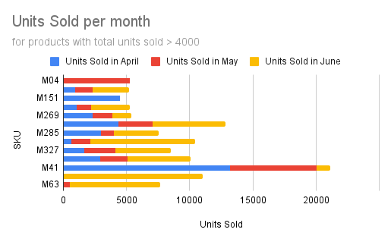

X-axis: SKU

Y-axis: Units sold (April, May, June)

This stacked bar chart will show the total units sold for each product in April, May, and June, allowing you to compare sales performance across the months as well as SKU’s.

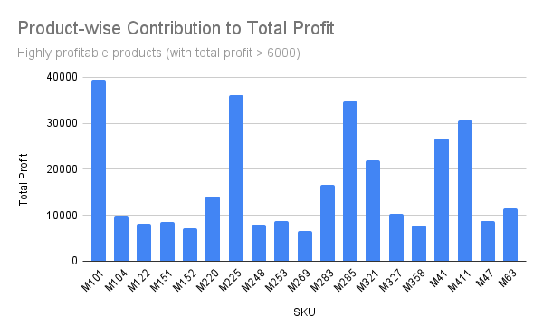

This bar chart will illustrate the contribution of each product to the total profit made from April to June 2023, helping us identify high-performing products in terms of profitability.

